TASK 2

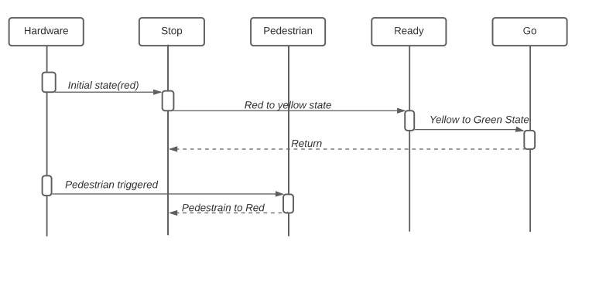

SEQUENCE DIAGRAM